Pinball League: HardHat Zone v1.1
Your favorite Pinball Table is getting even better! Enjoy impressive lighting quality on your desktop/tablet and even on your phone! The second major improvement in v1.1 is loading times, up to 40% faster on mobile devices.
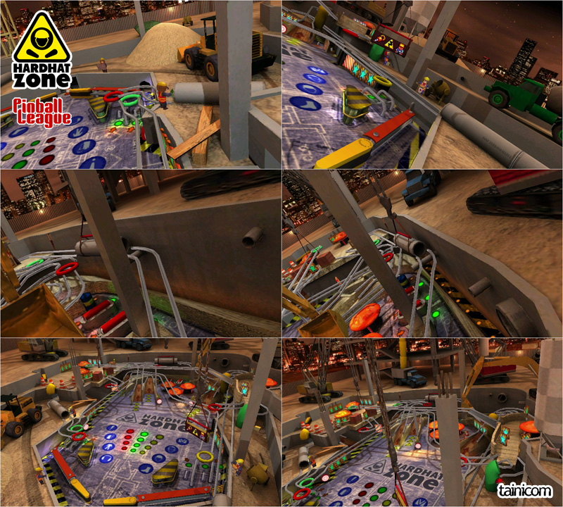
“Pinball League: HardHat Zone” is available on Windows Store for €1.99!
http://www.windowsphone.com/s?appid=6e5d76ca-85d8-4f87-bf96-0840214d03dc
http://apps.microsoft.com/windows/app/pinball-league-hardhat-zone/084daf06-5b6a-4c86-98d7-e6edec202bc6

Pinball league: HardHat Zone
“HardHat Zone” is the third pinball game by tainicom, originally released on October 16, 2014 on the Windows Store in collaboration with AppCampus. Having the mobile/tablet format as a target we had unique challenges and opportunities and we opted for an equally unique approach to the game. We make sure that we design tables that everyone can enjoy playing and looking at.

tainicom
“tainicom” is an indie studio focusing primary on mobile games and applications. It was founded in 2010 by two Greek developers with many years of experience and a passion for classic gaming values.

tainicom
Athens Greece, March 26, 2015

